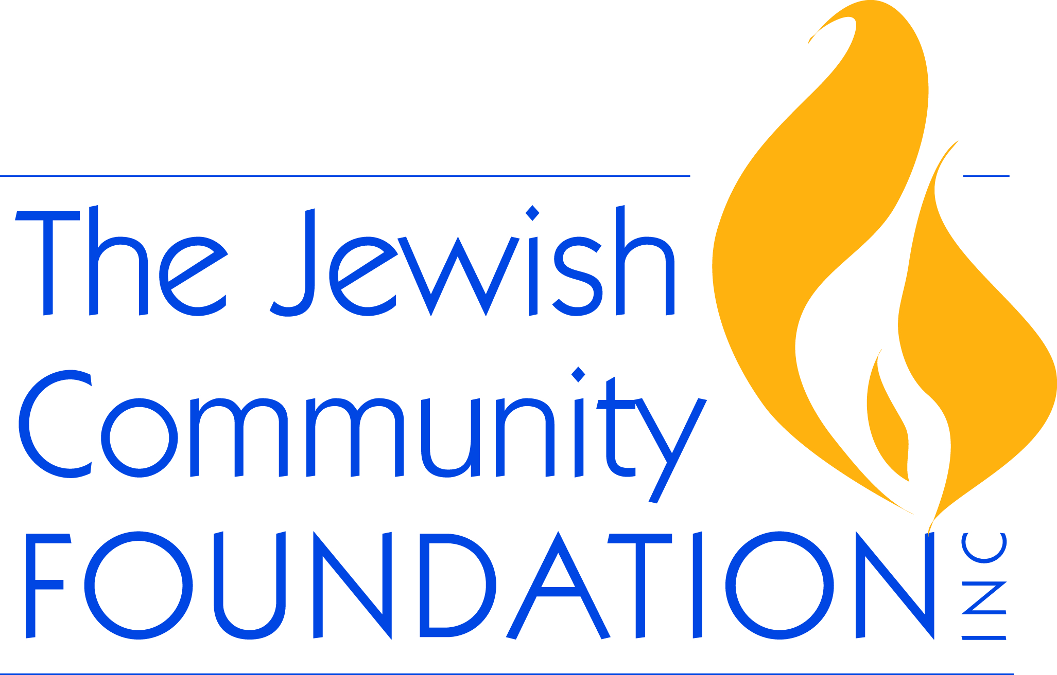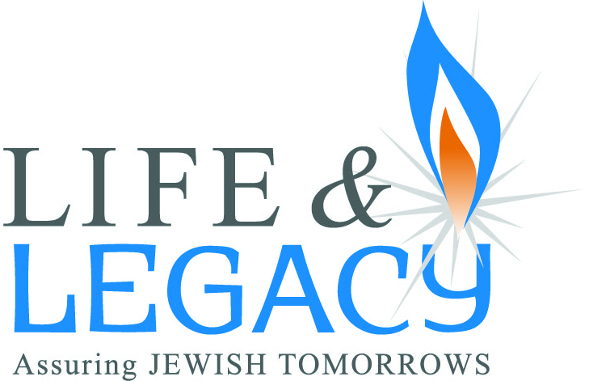

LEGACY STEWARDSHIP CHECKLIST
_______ Send a personalized handwritten thank you note

_________ Within 48 hours of receiving Declaration of Intent
_________ Within 48 hours of receiving confirmation of formalized gift

_________ Periodically to show appreciation for their commitment

_______ Personal phone call

________ A week after receiving Declaration of Intent

________ A week after receiving confirmation of formalized gift

_________ Periodically to stay in touch and keep informed/engaged

________ Personal meetings
_________ To discuss formalization of commitment

_________ Periodically to stay in touch and keep informed/engaged

_______ Keep accurate records of all interactions with donor – separate file for each

_______ Donor Recognition
_______ Public listings – website, newsletters, annual report, in lobby, in event materials
_______ Personal notes/cards – birthdays, holidays, with articles of interest, with invitation to organizational event
_______ Special legacy donor events – to honor their commitment to your organization

_______ Small gifts – if fits with your organization’s culture

_______ At organizational events – annual meeting, gala, major donor’s event

_______ Ongoing Communication – Letters/Newsletters – minimum of 4 times a year

_______ Engagement
_______ Ask to speak at or host a legacy event
_______ Invite to join a committee
_______ Invite to attend a non-legacy special event
_______ Honor at a Legacy Shabbat or other organizational event
_______ Share their story – Printed or video testimonial

_______ Use Funds Wisely
_______ Invest endowment funds with trusted partner
________ Maintain a state of financial well-being
________ Use donor’s funds as they intended
________ Report Your Impact
_________ In newsletters and letters
_________ In annual reports and at annual meetings
_________ On website
_________ Organize and manage stewardship in conformity with the Donor Bill of Rights
_________ Other Stewardship Activities
__________ ___________________________________________________________
__________ ___________________________________________________________
__________ ___________________________________________________________
Developed by Arlene D. Schiff, National Director
LIFE & LEGACY, Harold Grinspoon Foundation

